KAMPALA JUNIOR ACADEMY – KITANTE
P.1 LITERACY I TERM I 2020

NAME: ___________________________________________STREAM: _______
WEEK ONE
1. A place where people go to learn is a __________________
2. Who cooks food at school?
______________________________________________________
3. A teacher uses ________________to write on the blackboard. (duster, chalk)
4. Where do we find the following people?
sickbay
library
kitchen
gate
classroom
a) cook ________________
b) gatekeeper _________________
c) teacher ________________
d) nurse ________________
e) librarian
5. Underline the activities done by children at school.
reading teaching fighting writing abusing
6. Name these things we use at school.

7. Write out the school symbols from the list below.
badge _______________
teacher ___________________
uniform __________________
flag _________________
swing
sign post
8. Draw the things we use to clean the school.
brooms | rag | rake | water

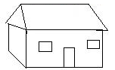
9. Match correctly.
medicine
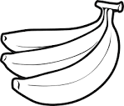
water

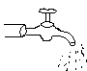food

shelter

10. Draw these houses.
hut | shrine | flat | bungalow

12. Write the source of these building materials.
cement lake shore
bricks hardware
timber forests
sand factory
13. Fill in the missing letters.
a) b___ng___low (b) t___nt c) igl____ ____
d) unip___rt (e) h___t (f) fl___t
14. A ________________is a building where people live.
15. Draw these people at home.
sister | grandmother | grandfather
mother | baby | brother
16. Where are the people found in a school?
a) Teacher ______________________
b) Nurse _____________________
c) Bursar _____________________
d) Headteacher ____________________
e) Cook _____________________
17. Match correctly
teachers cook food
cooks cares for sick pupils
headteacher teach pupils
nurse heads a school

18. Draw these activities done at school.
dancing | playing | teaching | reading

19. Name these things used to keep our school clean.
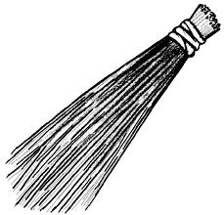 |  | 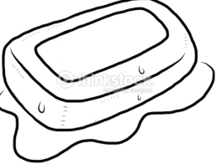 | 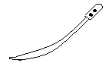

20. How do we keep our school clean?
a) by ____________________ b) by ____________________
(sweeping, slashing, mopping)
21. What do we call a place where people or animals live?
_____________________________________________________
22. Who heads a family?
_____________________________________________________
23. Father and mother are our ____________________
(friends, parents)
24. Name these things found at home.
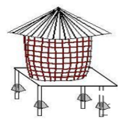

______________________ _____________________
25. Name these activities done at home.
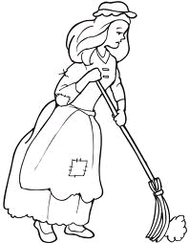 | 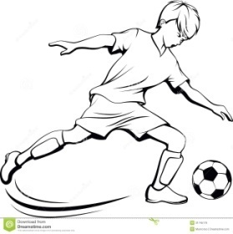 | 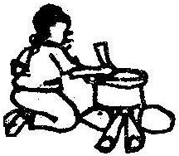
(sweeping, playing, pounding, cooking)
27. Project work
Dear parents / guardians, thank you for the support rendered to our future leaders in our effort to enhance their academic progress. We request you to help your child cut out and paste the following types of houses onto the cupboard or manila paper. This project work should be brought to class on the next reporting day.
flat, bungalow, igloo , hut, uniport, tent, kiosk, mud houses

